**CREATE LIGHTSAIL INSTANCE IN AWS**

1. **Objective :**

* How to create and configure LightSail instance in AWS.

1. **Scope and Definition :**
2. A LightSail instance is a virtual private server (VPS) that lives in the AWS Cloud.
3. Your instances can connect to each other and to other AWS resources through both public (Internet) and private (VPC) networking.
4. You can create, manage, and connect easily to instances right from the LightSail console.
5. This guide will walk you through, to configure the creation process of LightSail instance in AWS.
6. **Instruction :**

In LightSail, running an application like WordPress or a development stack like LAMP in seconds. After your instance starts running, you can connect to it via SSH without leaving LightSail. Here's how,

* 1. Sign in to the AWS Management Console and open the LightSail at

https://lightsail.aws.amazon.com/ls/webapp/home/instances

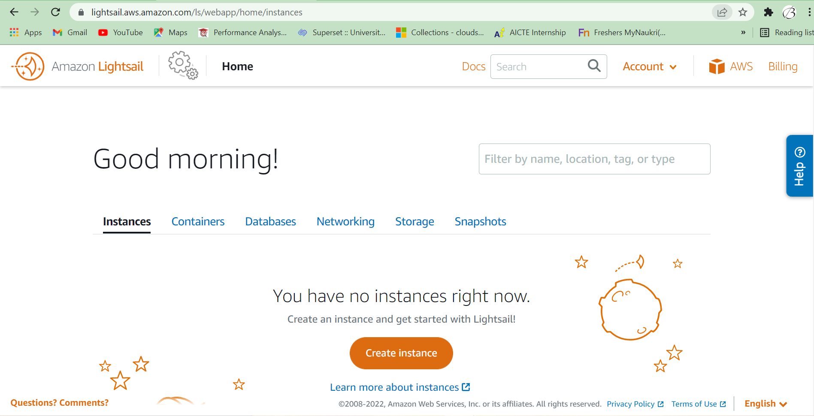

2. If this is your first creation, on the home page choose Create instance.

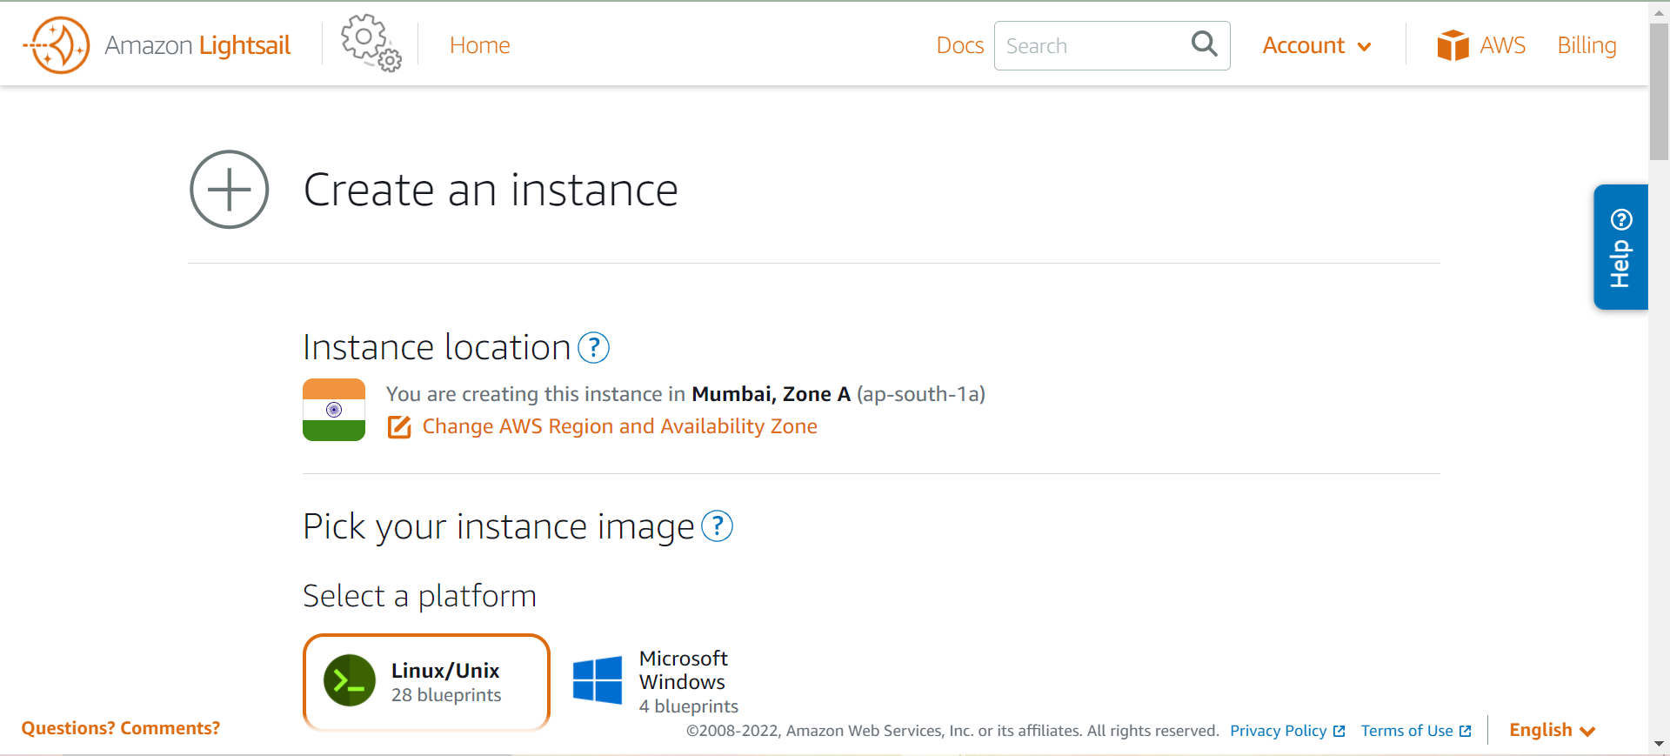

3 .Select a location for your instance (an AWS Region and Availability Zone).

Choose Change Region and zone to create your instance in another location.

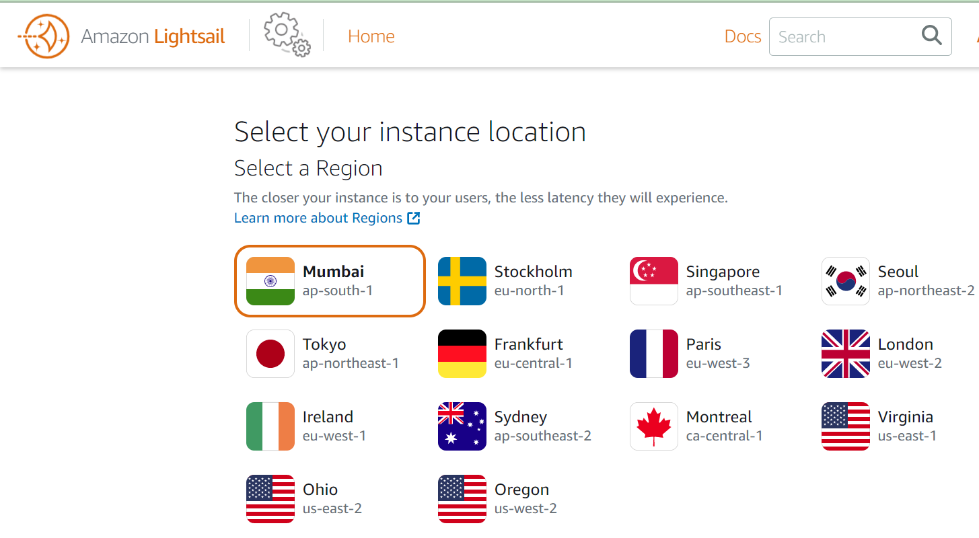

1. Optionally, you can change the Availability Zone. Choose an Availability Zone from the dropdown list.

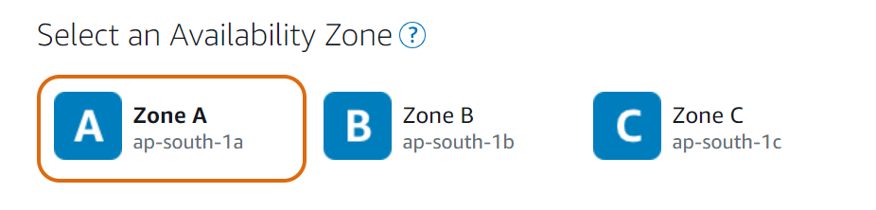

5. Pick an application (Apps + OS) or an operating system (OS Only).

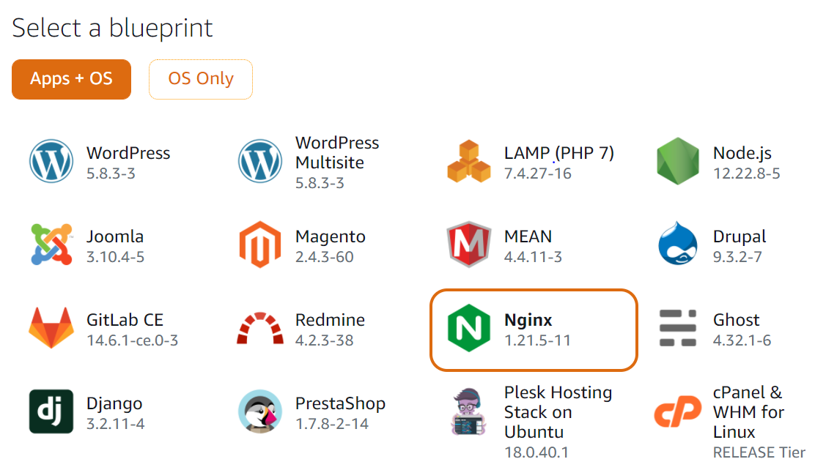

1. .Choose your instance plan. You can try the $3.50 USD LightSail plan free for one month (up to 750 hours). We will credit one free month to your account.

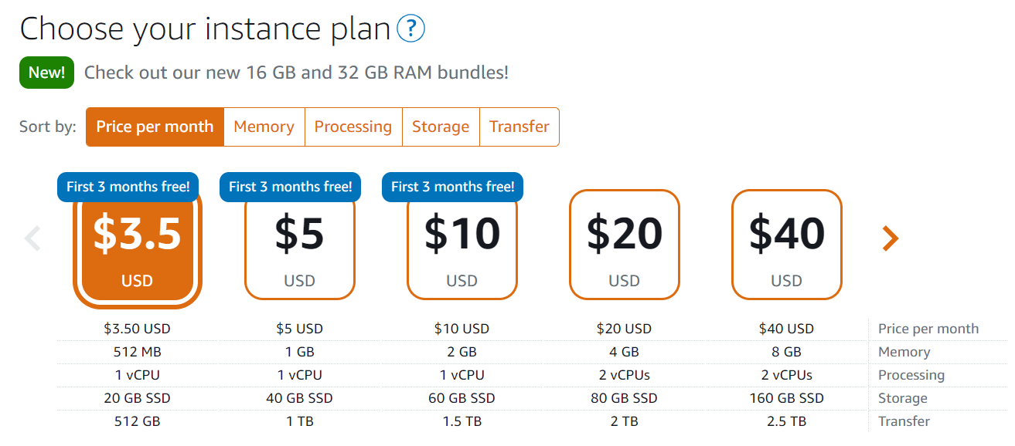

* Linux/Unix instance plans: $3.50 USD per month, $5 USD per month, and $10 USD per month
* Windows instance plans: $8 USD per month, $12 USD per month, and $20 USD per month

7 .You can enter user data to configure the instance type you've chosen.

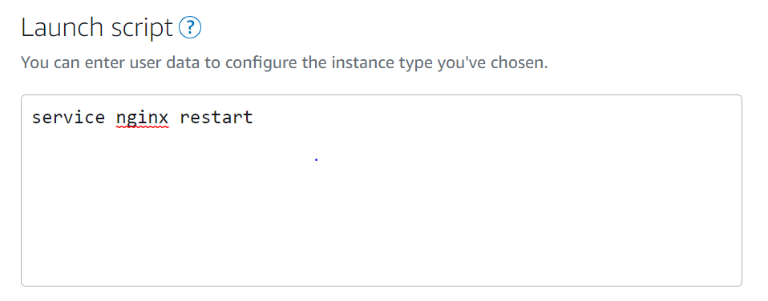

8 .Enter a name for your instance.

Resource names:

* + Must be unique within each AWS Region in your LightSail account.
  + Must contain 2 to 255 characters.
  + Must start and end with an alphanumeric character or number.
  + Can include alphanumeric characters, numbers, periods, dashes, and underscores.

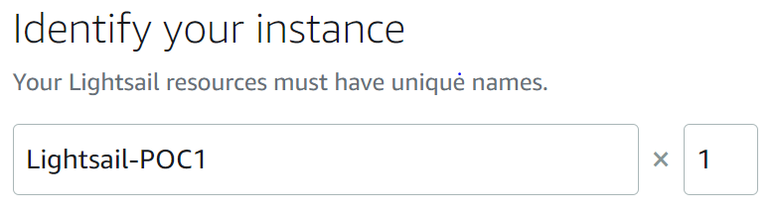

9 .Choose Create instance.

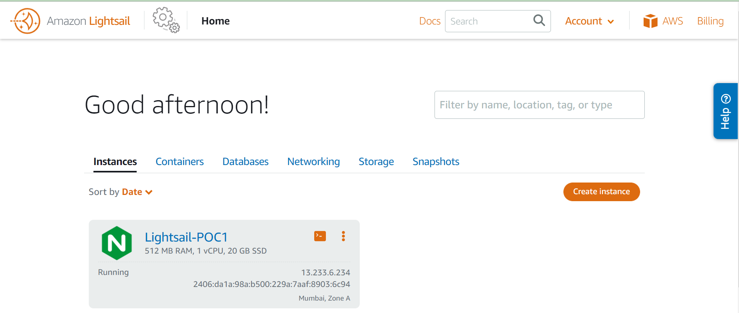

10 .Hit the IP address in the browser 13.233.6.234. You will see the default page of Bitnami NGINX.

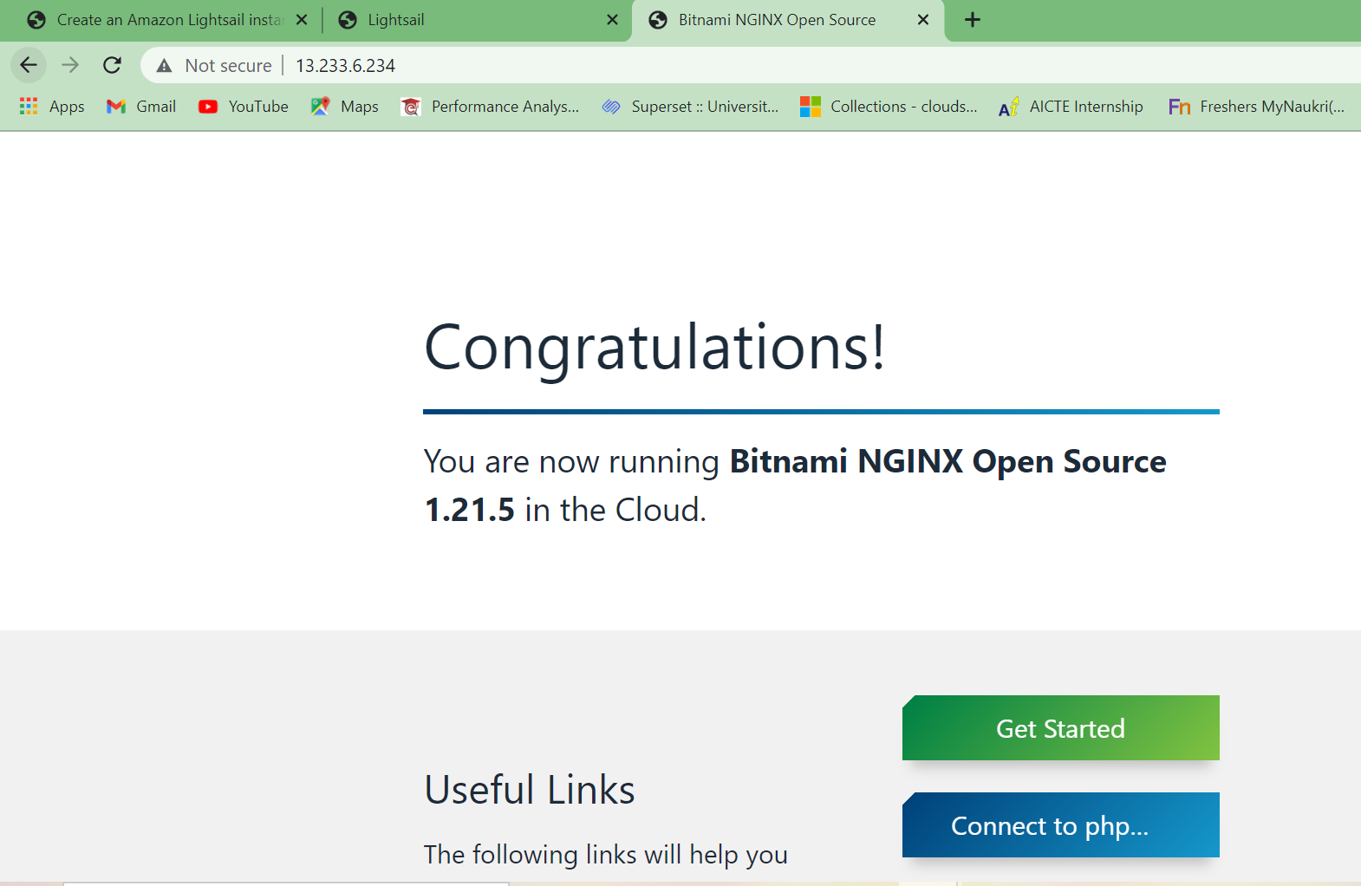

1. In the networking part :

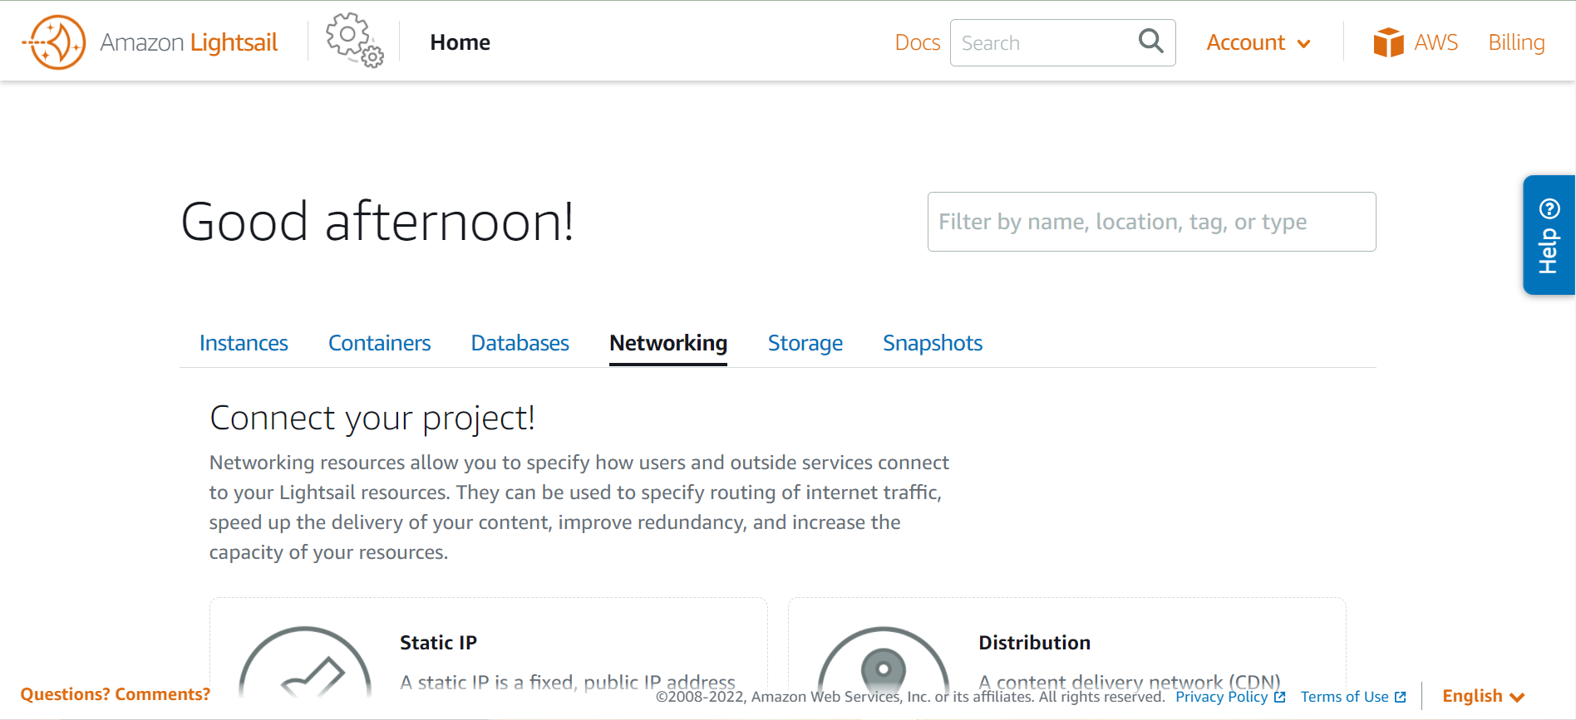

* 1. Static IP: A static IP is a fixed, public IP address that you can attach to an instance.
  2. If you want the make the 13.233.6.234 IP as static IP. We can change it as static IP here,

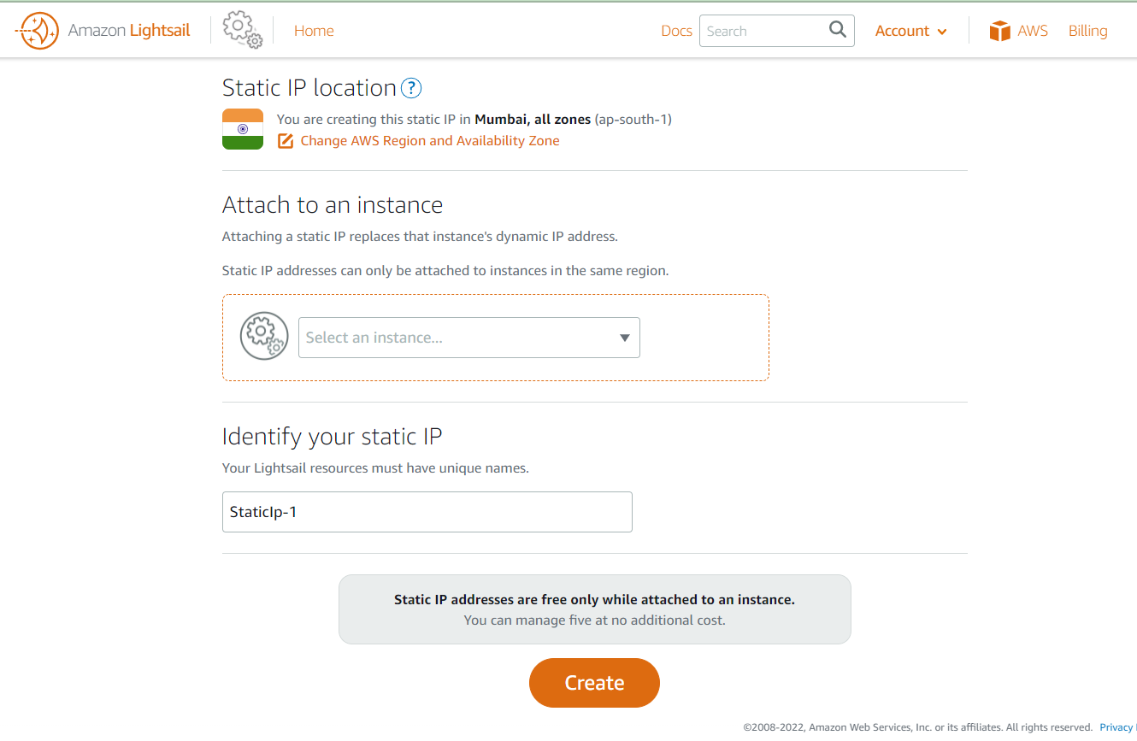

12 . To reduce the network between user to origin server :

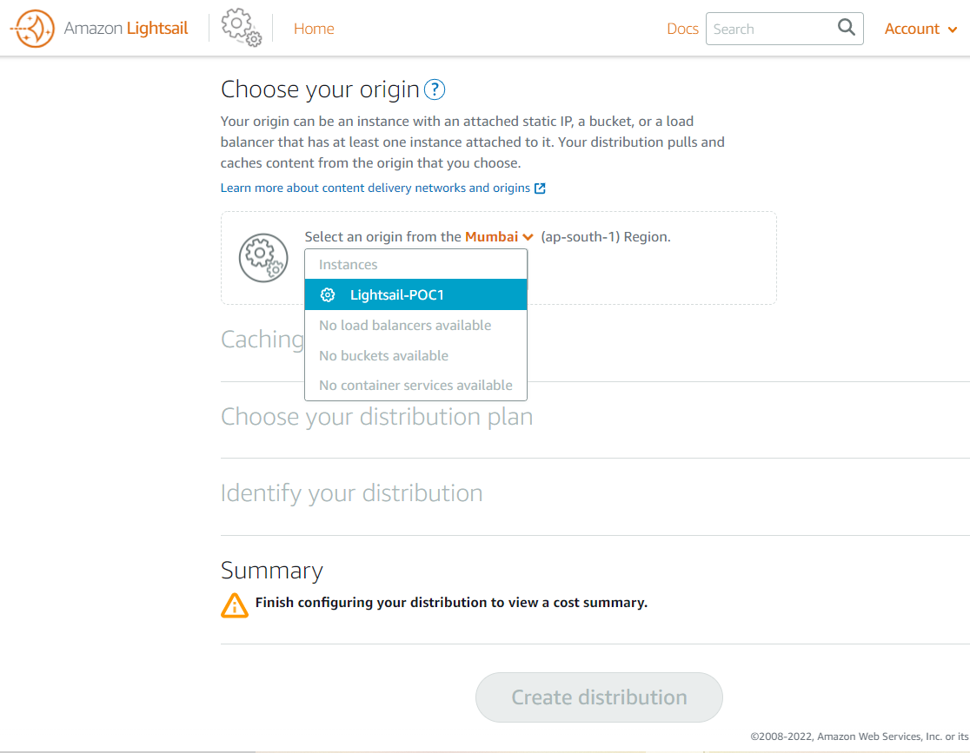

13 .To make the server high available and the distributes the load across the backend pool. Create load balancer.

In load balancer we need to attach another machine to make the server high available – If one server got down it redirect to the another server.

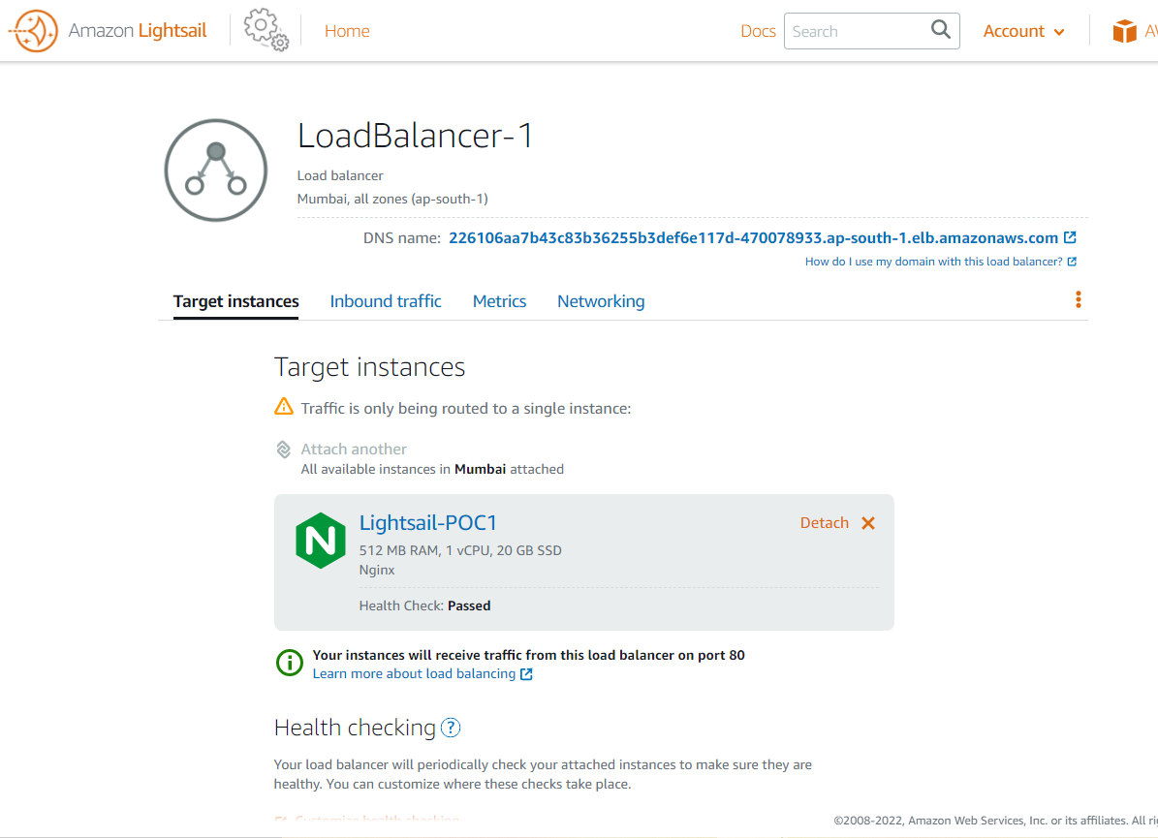

14 .If you want to name the IP address we can go with create DNS.

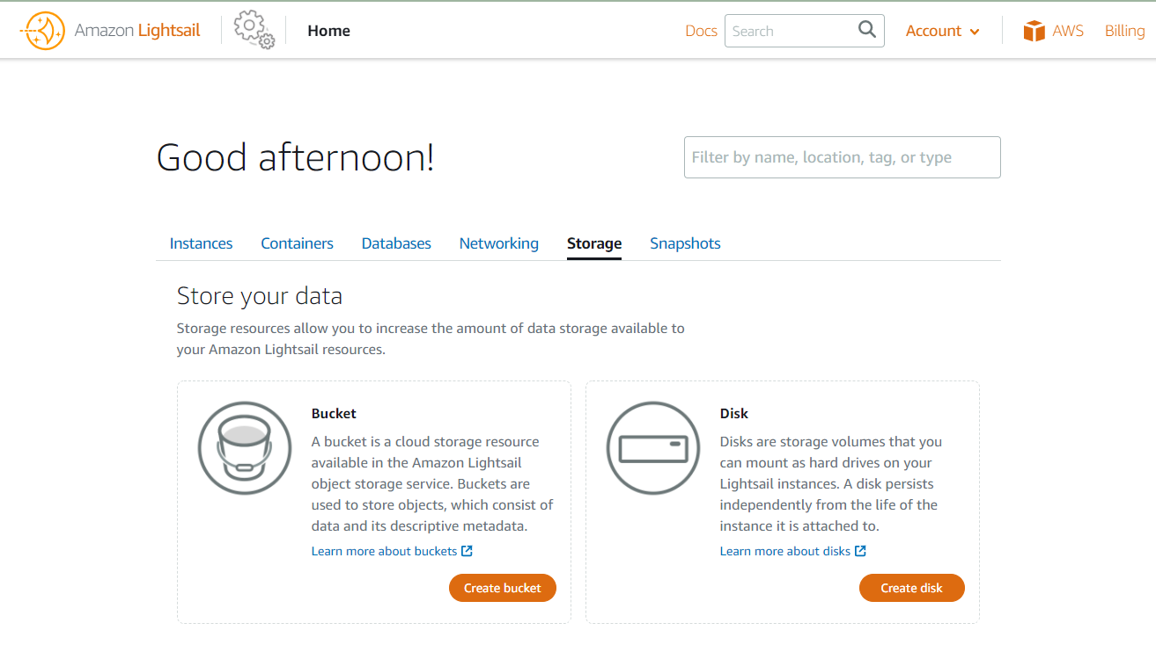

15. To add the storage

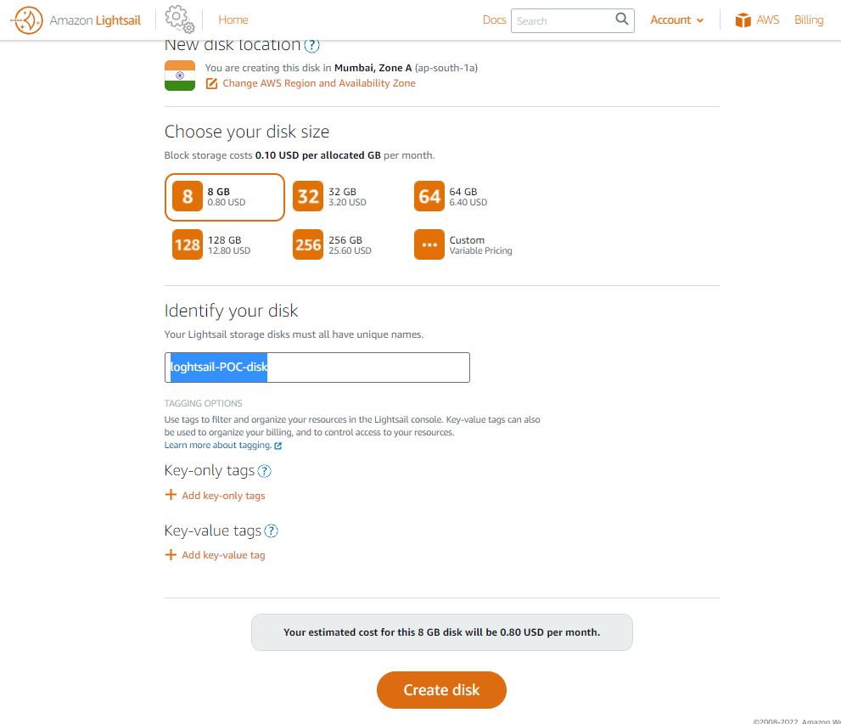

16 .If you want to take a backup of any machine or to backup the machine we can use Snapshots :

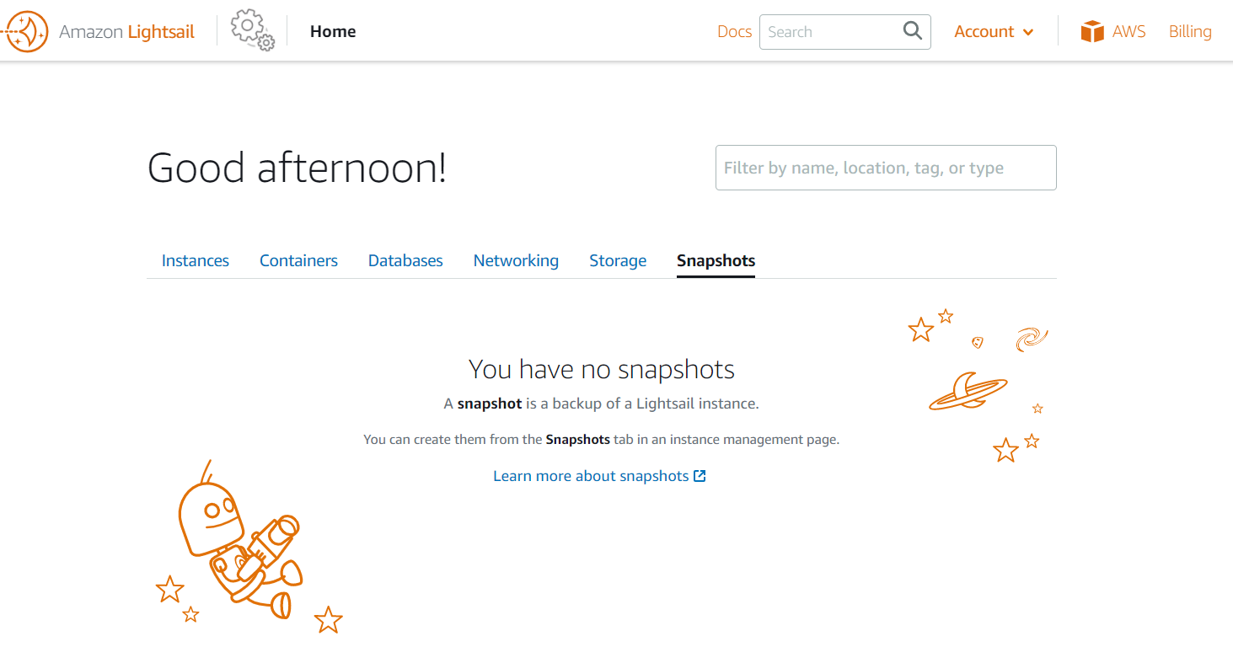

# Reference :

External Link : https://lightsail.aws.amazon.com/ls/docs/en_us/articles/how-to-create-amazon-lightsail-instance-virtual-private-server-vps

|  |  |  |  |  |
| --- | --- | --- | --- | --- |
| Version number | Version Date | Prepared By | Reviewed By | Review Date |
| 0.1 | 18-Feb-2022 | Bharathi R | Rajkumar |  |